1. Trần Thị Thu Trang - CMC CORPORATION (HOSE: CMG)
2. **Introduction.**

CMC CORPORATION (HOSE: [CMG](https://finance.vietstock.vn/CMG-ctcp-tap-doan-cong-nghe-cmc.htm)), formerly ADCOM Center, under the Institute of Microelectronics Technology, National Institute of Technology established 1991 - 1993, the center changed its name to CT TNHH HT&NT. On February 7, 2007, CMC equitized officially converted into a CMC Corporation with 13 founding shareholders who are key leaders of the company and of its member companies. CMG is also known as a large company in the information technology industry in Vietnam with 108 million shares outstanding. Currently, the main shareholders of CMC include Samsung SDS Asia Pacific Pte.Ltd, MVI Investment Co., Ltd and Geleximco Group with shares of 29.88%, 13.5% and 10.01% respectively.

The company is currently doing business in different fields and industries, but mainly related to information technology and application of information technology such as: Providing science and technology services, hardware and software production, telecommunications network, educational consulting,....

1. **Analysis of CMC's gross sales revenue.**
2. Forecast for Gross Sales Revenue of CMG

To analyze the quarterly gross sales revenue of CMG, we will use 8 models using time series data of CMG's quarterly gross sales revenue since Q1 2009 until 2022Q4 to test.

| Data from 2009Q1 to 2022Q4: t = 56 | Forecast |  |  |  |
| --- | --- | --- | --- | --- |
|  | 2023: Q1:  t = 57 | 2023: Q2:  t = 58 | 2023: Q3:  t = 59 | 2023: Q4:  t = 60 |
| 1. **LINEAR – LINEAR: $GSR_{t}= 727657 + 14278*t+e_{t}$** | 1541503 | 1555781 | 1570059 | 1584337 |
| 1. **LINEAR – LOG : $GSR_{t}= 545740 + 191319*lnln \left(t\right) +e_{t}$** | 1319253 | 1322580 | 1325850 | 1329066 |
| 1. **LOG – LINEAR: $GSR_{t}=expexp \left(13.445942 + 0.014653*t+e_{t}\right)$** | 1593053 | 1616568 | 1640430 | 1664644 |
| 1. **LOG – LOG $ln⁡(GSR_{t})= 13.2114 + 0.2119 ln(t) + e_{t}$** | 1287384 | 1292137 | 1296826 | 1301453 |
| 1. **LINEAR TREND + SEASONAL**   **(ADDITIVE FORM) $GSR_{t}= 576035+13524*t+32127*s_{2}$ $+186775*s_{3}+473507*s_{4}+e_{t}$** | 1346903 | 1392554 | 1560726 | 1860982 |
| 1. **LINEAR TREND + SEASONAL**   **(MULTIPLICATIVE FORM) $GSR_{t}= 439779 + 18570*t + 116119*s_{2}$ $+ 208988*s_{3} + 935130*s_{4} - 3180*t*s_{2}$ $- 1114*t*s_{3} -15892*t*s_{4}+e_{t}$** | 1498269 | 1448518 | 1660101 | 1498449 |
| 1. **HO LT-WINTES ANALYSIS**   **( ADDITIVE FORM) : t = 56 + k $GSR_{T+k}^{F}=(1984722.7 + 43389.78*k) +S_{appropriate}$** | 1831361 | 1831361 | 2076271 | 2386134 |
| 1. **HO LT-WINTES ANALYSIS**   **( MULTIPLICATIVE FORM) : t = 56 + k $GSR_{T+k}^{F}=(2176651 + 100178.1*k*S_{appropriate}$** | 1990556 | 2004176 | 2325173 | 2683089 |

1. Compare among model.

|  | **RMSE** | **MAPE** | **RMSE**  For last 4 obs | **MAPE**  For last 4 obs |
| --- | --- | --- | --- | --- |
| 1. **LINEAR – LINEAR** | 468381.9 | 21.81% | 836135.4 | 39.81 % |
| 1. **LINEAR – LOG** | 493703 | 26.56% | 821571 | 39.81 % |
| 1. **LOG – LINEAR** | 463439.6 | 17.98 % | 893856.7 | 42.778 % |
| 1. **LOG – LOG** | 493290.1 | 22.833 % | 887633.9 | 43.43 % |
| 1. **LINEAR TREND + SEASONAL**   **(ADDITIVE FORM)** | 429491.4 | 19.45 % | 806650.9 | 40.85% |
| 1. **LINEAR TREND + SEASONAL**   **(MULTIPLICATIVE FORM)** | 417049.2 | 19.772% | 813153.4 | 40.85% |
| 1. **HOLT-WINTES ANALYSIS**   **( ADDITIVE FORM)** | 966781.2 | 64.414% | 1467855 | 69.014% |
| 1. **HOLT-WINTES ANALYSIS**   **( MULTIPLICATIVE FORM)** | 939495.5 | 60.478% | 1470037 | 68.897 % |

It can be seen that the difference between the MAPE of the whole data and the MAPE of the last 4 observations is not too large, it shows that found that the above model can be suitable for analyzing quarterly data of the company.

Compare the MAPE of the whole data between the models, the MAPE of model which is smaller, the model is better. It can be seen that the log-linear model is better than other models. MAPE of the last 4 observations between models, MAPE of 2 models is linear-log and linear-linear models is better than others.

1. Analyze CMG's closing price using the ARIMA model.
2. **Plot: CMG trend : non-stationary.**

Looking at the figure of ACF and PACF of the CMG's close price, it is easy to see that the sequence is a random step where ACF shows the correlation of continuous periods with each other. With Dickey-Fuller test, we have $\left|τ_{stat}\right|=\left|-1.2154\right| < \left|τ_{α}\right|$, the test results make it even more clear that the CMG’s close price is non-stationary.

| **Figure 1: Line plot of CMG’s close price** | **Figure 2: ACF and PACF of CMG’s close price** |
| --- | --- |

To check the stationary series, we will take the first difference of the series. It is clear from the ACF and PACF graphs of the first difference series that the series is stationary. Because Tau-test: $\left|τ_{stat}\right|=\left|-17.1247\right|> \left|τ_{0.05}\right|= \left|-2.87\right|$ so series $\left(∆cmg_{t}\right)$ has not unit root, stationary.

| **Figure 3: line plot of difference series**   | **Figure 4 : ACF and PACF of diffe rence series** |
| --- | --- |

1. **Find order of ARMA of stationary series: $∆cmg_{t}$**

Guest: AR(1), MA(3)

Model of Δ𝑐𝑝𝑖𝑡 is ARMA(1,3)

Model for CPI: ARIMA(1,1,3)

Original form: $∆cmg_{t}=μ+ϕ∆cmg_{t-1}+u_{t}+θ_{1}u_{t-1}+θ_{2}u_{t-2}+θ_{3}u_{t-3}$

Mean-adjusted form: $∆cmg_{t}-μ^{*}=ϕ\left(∆cmg_{t-1}-μ^{*}\right)+u_{t}+θ_{1}u_{t-1}+θ_{2}u_{t-2}+θ_{3}u_{t-3}$

1. **Estimate model ARIMA(1,1,3)**

$∆cmg_{t}-0.0153=0.918\left(∆cmg_{t-1}-0.0153\right)+u_{t}+\left(-0.9404\right)u_{t-1}+\left(-0.0593\right)u_{t-2}$

$+0.0833u_{t+3 }$

* Long-run mean is 0.0153
* AIC = 1614.32, BIC=1639.58

1. **Check for goodness of model: Model ARIMA(1,1,2)**

Forecasting model ARIMA(1,1,2), we get the following results:

$∆cmg_{t}-0.0159=-0.1874(∆cmg_{t-1}-0.0159)+u_{t}+0.1655u_{t-1}+(-0.0827)u_{t-2}$

The above model gives AIC = 1612.61, BIC = 1633.66, slightly lower than ARIMA(1,1,3). Based on criteria AIC, BIC as well as theories economic, the ARIMA(1,1,2) model will preferred choice.

Inverse roots: inside the unit circle: stationary

With model ARIMA(1,1,2) we use Ljung-Box test for check for the residuals of model. And we have result not reject $H_{0}$ is no serial correlation with P-value = 0.5119.

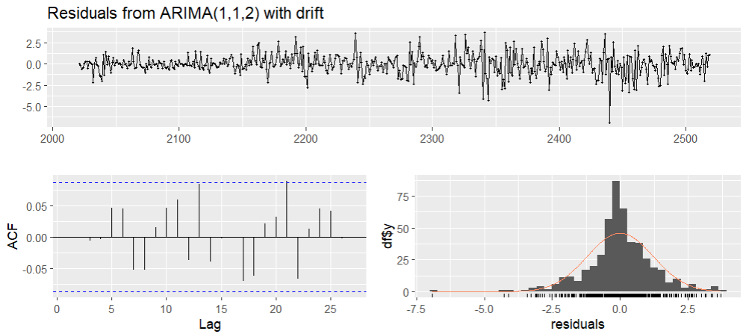

ACF: residual: white noise

Forecast equation:

$∆cmg_{t}-0.0159=-0.1874(∆cmg_{t-1}-0.0159)+u_{t}+0.1655u_{t-1}+(-0.0827)u_{t-2}$

$μ^{*}=0.0159 → \hat{μ}=0.0159\left(1-\left(-0.1874\right)\right)=0.0189$

$→∆cmg_{t}=0.0189+\left(-0.1874\right)∆cmg_{t-1}+u_{t}+0.1655u_{t-1}+(-0.0827)u_{t-2}$

1. Forecast for the 10 first observation in 2023.

| | Time | Real | Forecast | | --- | --- | --- | | 500 | 40.0000 | 39.90448 | | 501 | 41.5000 | 39.85393 | | 502 | 41.1000 | 39.88223 | | 503 | 41.2000 | 39.89575 | | 504 | 40.9500 | 39.91204 | | 505 | 40.0000 | 39.92781 | | 506 | 41.4000 | 39.94368 | | 507 | 40.8500 | 39.95953 | | 508 | 40.5000 | 39.97539 | | 509 | 40.2500 | 39.99124 | | we can see that the forecast value will match the actual value close to about 90% in a short time. The forecast value has deviated by about 5% compared to the actual value, the ARIMA(1,1,2) model cannot predict the close price of CMG. |
| --- | --- | --- | --- | --- | --- | --- | --- | --- | --- | --- | --- | --- | --- | --- | --- | --- | --- | --- | --- | --- | --- | --- | --- | --- | --- | --- | --- | --- | --- | --- | --- | --- | --- | --- |